COLOR | VALUE | MULTI-PLIER | TOLE-  RANCE
BLACK | 0 | x 1
BROWN | 1 | x 10 | ± 1%
RED | 2 | x 100 | ± 2%
ORANGE | 3 | x 1000
YELLOW | 4 | x 10 000
GREEN | 5 | x 100 000
BLUE | 6 | x 1000 000
VIOLET | 7
GREY | 8
WHITE | 9
GOLD |  | x 0.1 | ± 5%

RESISTOR COLOR CODES

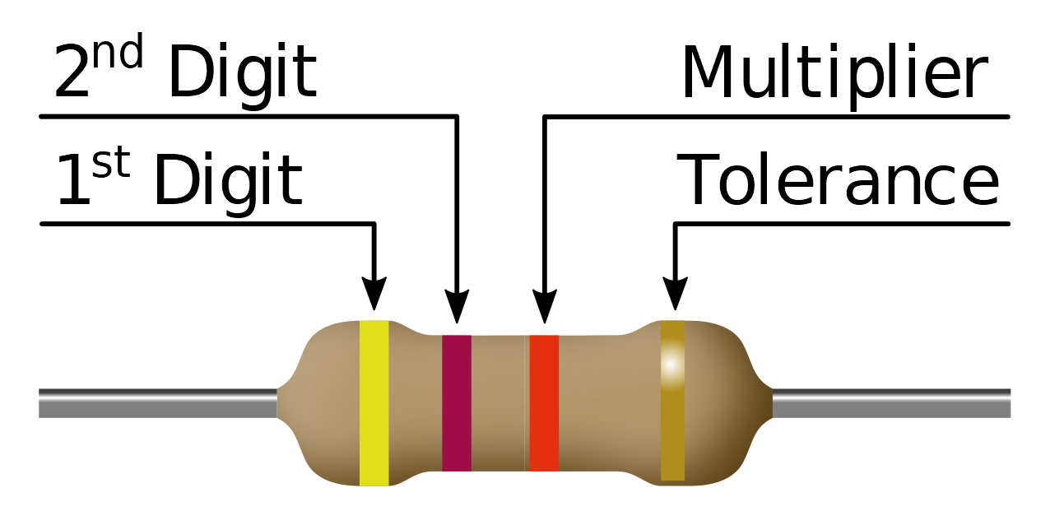
CC BY-SA 4.0 www.picuino.com
- Calculate the missing colors and resistors in the following tables..
- In the last column, calculate the current that will flow through the resistor when connected to a 9 volt battery.
- All values should be written to 3 decimal places and with the multiplier symbol that best corres-ponds to it (M=Mega, k=kilo, m=mili, μ=micro)

COMMERCIAL SERIES E6: (5%)

VALUE Ω | 1st DIGIT | 2nd  DIGIT | MULTI-PLIER | TOLE-RANCE |  | I = 9v / R
4.7 MΩ
 | RED | RED | BLACK | GOLD
15 Ω
 | ORANGE | ORANGE | GOLD | GOLD
10 kΩ
 | BROWN | GREEN | BROWN | GOLD
220 Ω
 | YELLOW | VIOLET | BLACK | GOLD
3.3 kΩ
 | RED | RED | RED | GOLD
100 Ω
 | BLUE | GREY | BROWN | GOLD
22 kΩ
 | BROWN | BLACK | YELLOW | GOLD
1.0 Ω
 | BLUE | GREY | ORANGE | GOLD
680 kΩ
 | ORANGE | ORANGE | GREEN | GOLD

COMMERCIAL SERIES E6: (5%)

VALUE Ω | 1st  DIGIT | 2nd  DIGIT | MULTI-PLIER | TOLE-RANCE |  | I = 9v / R
1.5 kΩ
 | YELLOW | VIOLET | RED | GOLD
2.2 Ω
 | BROWN | BLACK | BLACK | GOLD
2.2 MΩ
 | BROWN | GREEN | ORANGE | GOLD
330 kΩ
 | RED | RED | YELLOW | GOLD
4.7 Ω
 | BLUE | GREY | GREEN | GOLD
470Ω
 | BROWN | BLACK | RED | GOLD
47 kΩ
 | BROWN | GREEN | GOLD | GOLD
33 Ω
 | BROWN | GREEN | GREEN | GOLD
150 kΩ
 | BLUE | GREY | GOLD | GOLD
68 Ω
 | ORANGE | ORANGE | BROWN | GOLD
1 MΩ
 | ORANGE | ORANGE | ORANGE | GOLD
6.8 kΩ
 | YELLOW | VIOLET | YELLOW | GOLD

COLOR | VALUE | MULTI-PLIER | TOLE-  RANCE
BLACK | 0 | x 1
BROWN | 1 | x 10 | ± 1%
RED | 2 | x 100 | ± 2%
ORANGE | 3 | x 1000
YELLOW | 4 | x 10 000
GREEN | 5 | x 100 000
BLUE | 6 | x 1000 000
VIOLET | 7
GREY | 8
WHITE | 9
GOLD |  | x 0.1 | ± 5%

RESISTOR COLOR CODES

CC BY-SA 4.0 www.picuino.com

- Calculate the missing colors and resistors in the following tables..
- In the last column, calculate the current that will flow through the resistor when connected to a 9 volt battery.
- All values should be written to 3 decimal places and with the multiplier symbol that best corres-ponds to it (M=Mega, k=kilo, m=mili, μ=micro)

COMMERCIAL SERIES E6: (5%)

VALUE  Ω | 1st  DIGIT | 2nd  DIGIT | MULTI-PLIER | TOLE-RANCE |  | I = 9v / R
4.7 MΩ | YELLOW | VIOLET | GREEN | GOLD |  | 1,91 μA
22 Ω | RED | RED | BLACK | GOLD |  | 409 mA
15 Ω | BROWN | GREEN | BLACK | GOLD |  | 600 mA
3.3 Ω | ORANGE | ORANGE | GOLD | GOLD |  | 2,73 A
10 kΩ | BROWN | BLACK | ORANGE | GOLD |  | 900 μA
150 Ω | BROWN | GREEN | BROWN | GOLD |  | 60,0 mA
220 Ω | RED | RED | BROWN | GOLD |  | 40,9 mA
47 Ω | YELLOW | VIOLET | BLACK | GOLD |  | 192 mA
3.3 kΩ | ORANGE | ORANGE | RED | GOLD |  | 2,73 mA
2.2 kΩ | RED | RED | RED | GOLD |  | 4,09 mA
100 Ω | BROWN | BLACK | BROWN | GOLD |  | 90,0 mA
680 Ω | BLUE | GREY | BROWN | GOLD |  | 13,2 mA
22 kΩ | RED | RED | ORANGE | GOLD |  | 409 μA
100 kΩ | BROWN | BLACK | YELLOW | GOLD |  | 90,0 μA
1.0 Ω | BROWN | BLACK | GOLD | GOLD |  | 9,00 A
68 kΩ | BLUE | GREY | ORANGE | GOLD |  | 132 μA
680 kΩ | BLUE | GREY | YELLOW | GOLD |  | 13,2 μA
3.3 MΩ | ORANGE | ORANGE | GREEN | GOLD |  | 2,73 μA

COMMERCIAL SERIES E6: (5%)

VALUE  Ω | 1st  DIGIT | 2nd  DIGIT | MULTI-PLIER | TOLE-RANCE |  | I = 9v / R
1.5 kΩ | BROWN | GREEN | RED | GOLD |  | 6,00 mA
4.7 kΩ | YELLOW | VIOLET | RED | GOLD |  | 1,91 mA
2.2 Ω | RED | RED | GOLD | GOLD |  | 4,09 A
10 Ω | BROWN | BLACK | BLACK | GOLD |  | 900 mA
2.2 MΩ | RED | RED | GREEN | GOLD |  | 4,09 μA
15 kΩ | BROWN | GREEN | ORANGE | GOLD |  | 600 μA
330 kΩ | ORANGE | ORANGE | YELLOW | GOLD |  | 27,3 μA
220 kΩ | RED | RED | YELLOW | GOLD |  | 40,9 μA
4.7 Ω | YELLOW | VIOLET | GOLD | GOLD |  | 1,91 A
6.8 MΩ | BLUE | GREY | GREEN | GOLD |  | 1,32 μA
470Ω | YELLOW | VIOLET | BROWN | GOLD |  | 19,2 mA
1 kΩ | BROWN | BLACK | RED | GOLD |  | 9,00 mA
47 kΩ | YELLOW | VIOLET | ORANGE | GOLD |  | 192 μA
1.5 Ω | BROWN | GREEN | GOLD | GOLD |  | 6,00 A
33 Ω | ORANGE | ORANGE | BLACK | GOLD |  | 273 mA
1.5 MΩ | BROWN | GREEN | GREEN | GOLD |  | 6,00 μA
150 kΩ | BROWN | GREEN | YELLOW | GOLD |  | 60,0 μA
6.8 Ω | BLUE | GREY | GOLD | GOLD |  | 1,32 A
68 Ω | BLUE | GREY | BLACK | GOLD |  | 132 mA
330 Ω | ORANGE | ORANGE | BROWN | GOLD |  | 27,3 mA
1 MΩ | BROWN | BLACK | GREEN | GOLD |  | 9,00 μA
33 kΩ | ORANGE | ORANGE | ORANGE | GOLD |  | 273 μA
6.8 kΩ | BLUE | GREY | RED | GOLD |  | 1,32 mA
470 kΩ | YELLOW | VIOLET | YELLOW | GOLD |  | 19,2 μA

